USER INTERFACE DESIGN
EXPERIMENT 6
Topic: RAD Model for E-Waste Disposal Management System
NAME: Abhinandan ER
ROLL NO: 240701006

Introduction
RAD (Rapid Application Development) is a software development model that focuses on quick development using prototypes and continuous user feedback.
It reduces development time and improves user satisfaction.
It is mainly used for UI/UX-based applications like mobile and web apps.

Key Features
Navigation:
• Splash Screen
• Login
• Home
• Select Waste Category
• Waste Details
• Pickup Details
• Confirmation
• Track Status

User Actions:
• Login to the system
• Select waste category
• Enter waste details
• Schedule pickup
• Track request status
• View confirmation

Requirements
- User can log in to the system
- User can select type of e-waste
- User can enter item details
- User can schedule pickup
- User can provide address and contact details
- User can track pickup status
- User can view confirmation message

User Design
Wireframes are created using Axure tool.
The following screens are designed:
• Splash Screen
• Login Page
• Home Page
• Select Waste Category Page
• Waste Details Page
• Pickup Details Page
• Confirmation Page
• Track Status Page
Wireframe Explanation
• Splash → shows app loading screen
• Login → user enters credentials
• Home → shows main options (schedule, track, rewards)
• Category → user selects waste type
• Waste Details → user enters item info
• Pickup → user enters address and schedule
• Confirmation → shows success message
• Track Status → shows pickup progress

Construction Phase
Interactive prototype is created using Axure.
Screens are connected using OnClick interactions.
Flow:
Splash → Login → Home
Home → Category → Waste Details → Pickup → Confirmation → Track Status
Home → Track Status

Testing & Iteration
The prototype is tested using preview mode.
Improvements are made based on:
• Navigation flow
• Button placement
• User experience

Cutover Phase
Final prototype is completed and ready for implementation.
It can be shared with developers for further development.

Conclusion
RAD model helps in fast development and easy modification.
It is suitable for UI-based applications like E-Waste Disposal Management System.
OUPUT:-
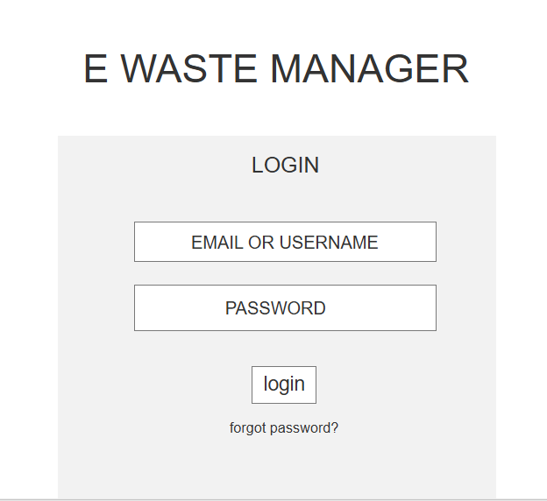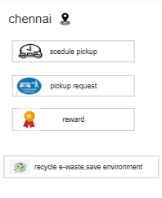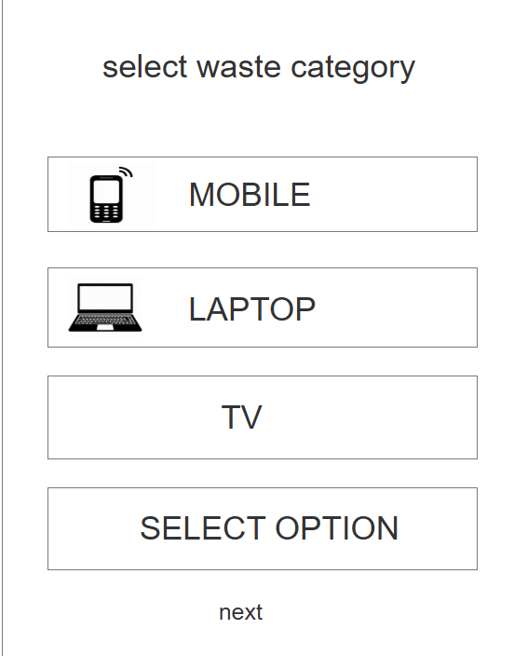

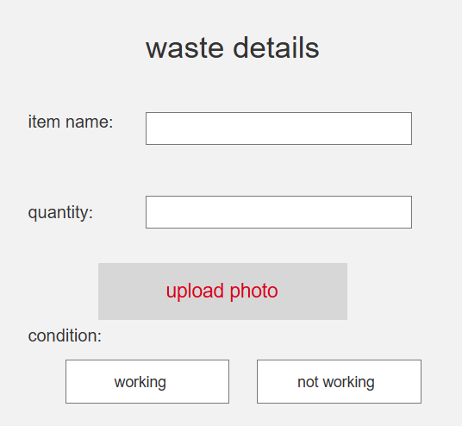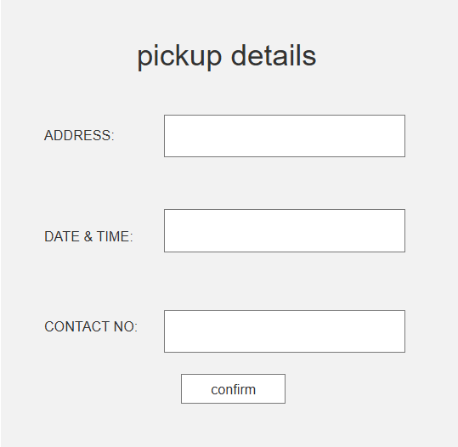
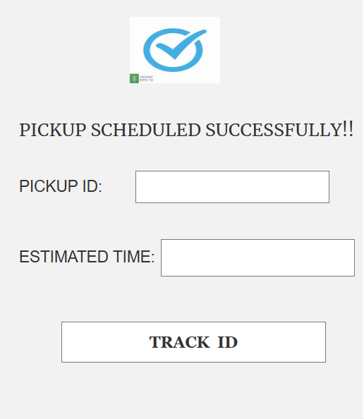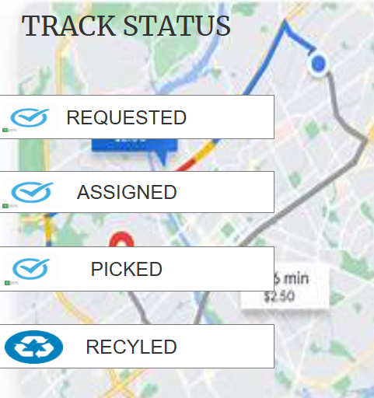
-------------------------------------------------------END------------------------------------------------------------------

